**Assignment – Solved**

* **Prajwal Waykos**
* Note – Both the codes are in the same file
* Also, I have provided my git-hub repository link where I have included everything required.

Code –

<https://github.com/Praj-17/Deep-Learning/tree/master/Pose%20Estimation/Using%20Mediapipe>

Humble request to please download and run the .ipynb file.

You can refer the following links to get in touch with me

Email

[prajwal.22010591@viit.ac.in](mailto:prajwal.22010591@viit.ac.in)

Resume

<https://drive.google.com/file/d/1NRxVPLk7A5e2BgRbTx8zP0ERaQfajYNx/view?usp=drivesdk>

LinkedIn

<https://www.linkedin.com/in/prajwal-waykos-a78105207/>

My Website

<http://prajtech.xyz/>

Git Hub

<https://github.com/Praj-17>

**Task – 1**

Input –



Output –

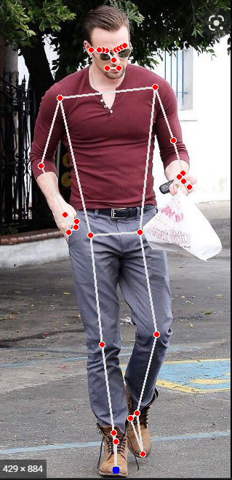

**Task – 2**

Output Video available at the following link

- <https://drive.google.com/file/d/1SRTAo81K6igy8U8sWP8PbgG-E3EQPDR9/view?usp=sharing>

**Task – 3 [optional]**

* Illustrate the process of creating a pose classification model with steps starting from ML package choice (tensorflow/pytorch) to testing the model.
* 1. First and for most we need to build up/find a related dataset.
* 2. Basically, the dataset should contain labeled data representing the location(co-ordinates) of the landmarks. As required in any custom detection model.
* 3. Once the data has been gathered we can move towards classifier building.
* Build embeddings based upon the landmark points. Exaclty like we do in FaceRecognition.
* 4 .We can build a a model that is able to classify the videos/images based upon the distances between the landmarks.
* 5. Then at last we can use any model such as, LSTM, Softmax, XGBoost, RandomForest etc for the embedding classification.

What method can be used as a feedback control loop in pose classification if a human pose estimation model is used to get the landmarks ? In simple words, can landmarks of body parts be used to validate the result from the pose classifier?

Answer -

Yes, We can put one Reinforcement model as a Feedback control loop(Though I don’t have much expertise in it). But yes it is possible by Reinforcement Learning.